VIT BHOPAL UNIVERSITY

COURSE CODE = CSA2001
FACULTY NAME = Dr. E.NIRMALA

NAME = NIHARIKA TANWI
REGISTRATION NO. = 25BOE10105
PROJECT TITLE= MOLECULE ACTIVITY PREDICTION USING MACHINE LEARNING

MOLECULE ACTIVITY PREDICTION USING MACHINE LEARNING
- INTRODUCTION
This project focuses on predicting whether a small molecule will be active or inactive against a specific protein target using Machine Learning. The dataset used is the inbuilt Breast Cancer dataset from Scikit-learn, which contains biologically relevant features extracted from tumor cells. These features help the machine learning model learn patterns that differentiate active and inactive molecular responses.
This prediction is important in drug discovery, where identifying active compounds early reduces cost, improves accuracy, and accelerates research.
- PROBLEM STATEMENT
Testing small molecules in the lab to see if they are active or inactive is slow and costly. This project uses machine learning with the Breast Cancer dataset to quickly predict a molecule’s activity, helping make the process faster and more efficient.
- FUNCTIONAL REQUIREMENTS
FR1: Load the Breast Cancer dataset.
FR2: Preprocess and split the data.
FR3: Train ML models for activity prediction.
FR4: Predict active or inactive output.
FR5: Show accuracy and results.

- NON- FUNCTIONAL REQUIREMENTS
NFR1: The system should give accurate and reliable predictions.
NFR2: It should run smoothly and respond quickly during training and testing.
NFR3: The code should be easy to understand and simple to use.
NFR4: The system should handle data properly without errors.
NFR5: It should be easy to update or improve the model in the future.

- SYSTEM ARCHITECTURE
Dataset → Preprocessing → Model Training → Testing → Activity Prediction
6.CODE STRUCTURE
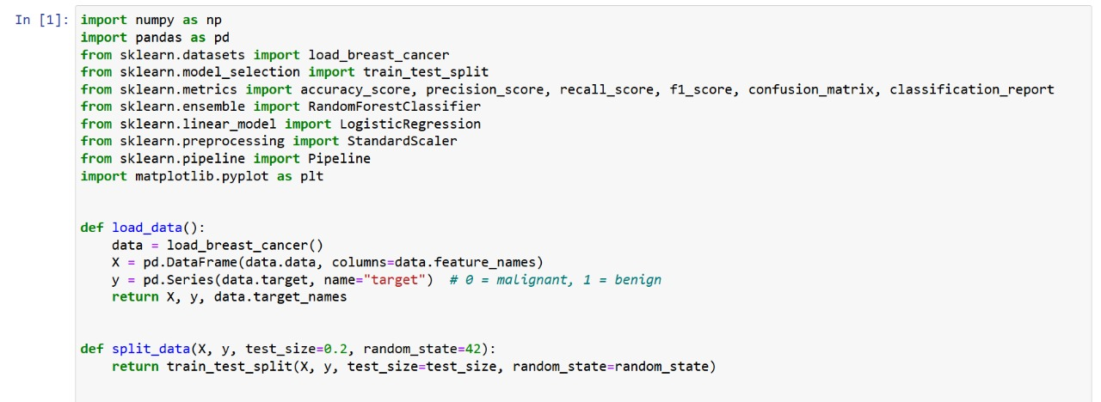
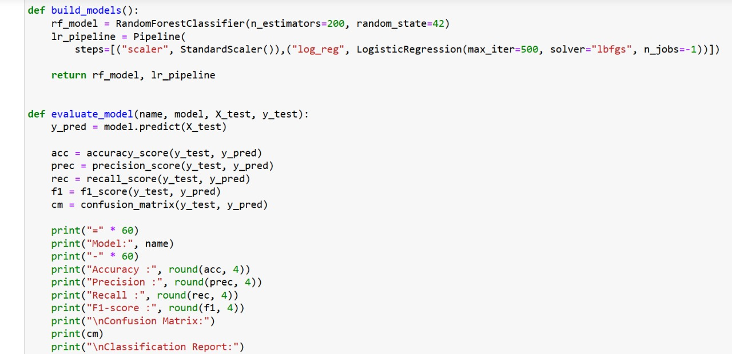

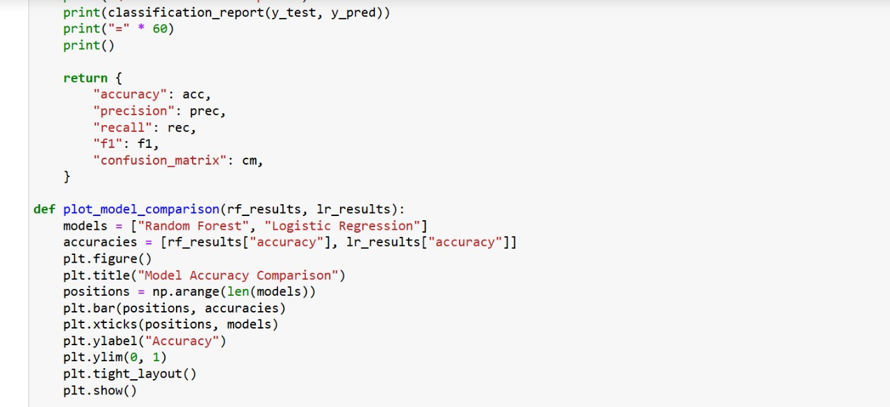
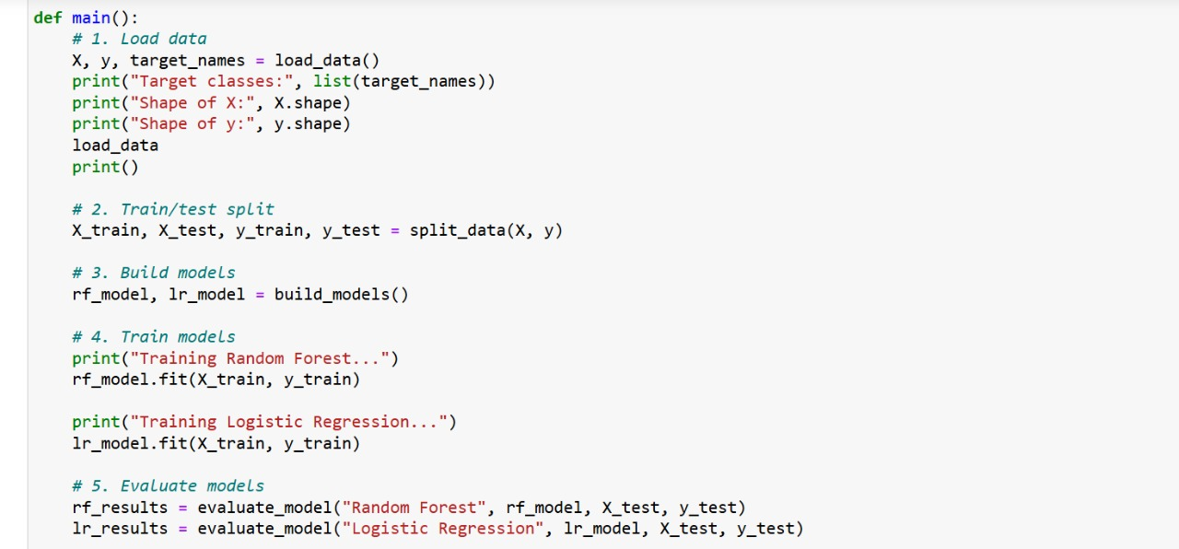

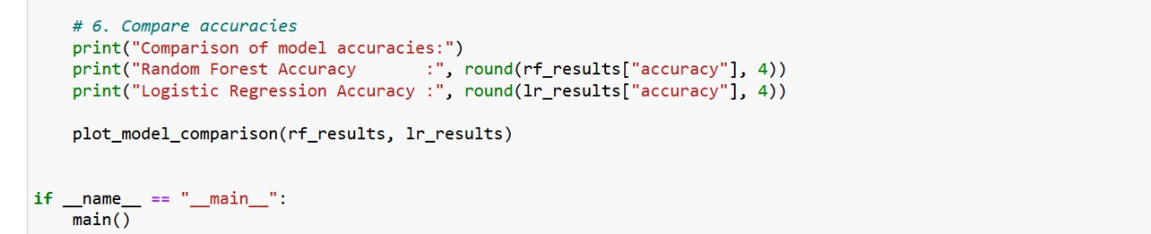

7.IMPLEMENTATION DETAILS
The system loads and preprocesses the Breast Cancer dataset, trains machine learning models, and then tests them on new data. Finally, it predicts whether a sample is active or inactive and shows the accuracy.

8.TESTING APPROACH
The model was tested on data it hadn’t seen before to check how accurately it predicted active or inactive results.

9.CHALLENGES FACED
A main challenge was choosing the best model, as some gave lower accuracy. Preprocessing the data correctly was also important, and the model sometimes misclassified samples until tuning improved the results.

10.LEARNINGS
PYTHON FUNCTIONS
MACHINE LEARNING
PROJECT STRUCTURE
GITHUB WORKFLOW

11. FUTURE ENHANCEMENTS
BETTER USE OF DATASET
REAL TIME TESTING
MORE INTERACTIVE
ADVANCED MODELS

12. REPOSITORY LINK
niharikatanwi/molecule-activity-prediction-ML: This project uses machine learning to predict whether a small molecule is active or inactive against a protein target. Using the inbuilt Breast Cancer dataset, the system preprocesses the data, trains models, evaluates accuracy, and provides fast, reliable activity predictions.

